# LAB#04

**IP addressing & subneting *.***

To Study about basics of IP addressing & subneting .

## Theory:

**IP Addressing:**

An IP address is an address refers to the Internet Protocol used in order to uniquely identify a device on an IP network. The 32 binary bits are broken into four octets (1 octet = 8 bits). Each octet is converted to decimal and separated by a period (dot). For this reason, an IP address is said to be expressed in dotted decimal format (for example, 172.16.81.100). The value in each octet ranges from 0 to 255 decimal, or 00000000 - 11111111 binary.

For example 205.112.45.60 could be written as:

11001101.01110000.00101101.00111100

The address is made up of 32 binary bits, which can be divisible into two parts by their subnet mask:

* Network portion
* Host portion

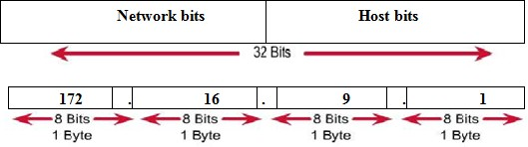

## Classful Addressing:

IPv4 addressing used the concept of classes. This architecture is called classful addressing. The address space is divided into five classes: A, B, C, D, and E. Each class occupies some part of the address space.

We can find the class of an address when given the address in

Binary notation or dotted-decimal notation.If the address is given in binary notation, the first few bits can immediately tell us the class of the address. If the address is given in decimal- dotted notation, the first byte defines the class.

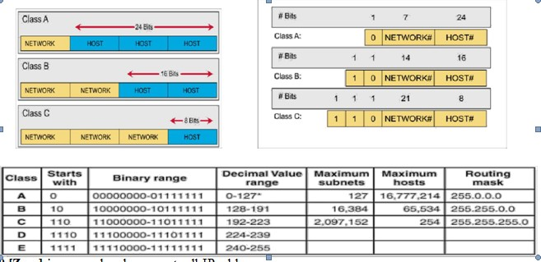

**0 [Zero]** is reserved and represents all IP addresses.

**127** is a reserved address and is used for testing, like a loop back on an interface.

## Subnetting:

Subnetting is a process of breaking large network in small networks known as subnets. Subnetting happens when we extend default boundary of subnet mask. Basically we borrow host bits to create networks.

With subnetting you only need to purchase single range of class C. You can configure router to take first 26 bits instead of default 24 bits as network bits. In this case we would extend default boundary of subnet mask and borrow 2 host bits to create networks. By taking two bits from the host range and counting them as network bits, we can create two new subnets, and assign hosts them. As long as the two new network bits match in the address, they belong to the same network. You can change either of the two bits, and you would be in a new subnet.

**Subnet mask:**

A 32-bit Subnet mask used to describe which portion of an address refers to the network and which part refers to the host. Subnet Mask is made by setting **network bits to all "1"s** and **setting host bits to all "0"s**.

* Follow these steps to determine the subnet mask:

1. Express the subnetwork IP address in binary form.
2. Replace the network and subnet portion of the address with all 1s.
3. Replace the host portion of the address with all 0s.
4. Convert the binary expression back to dotted-decimal notation.

For example if you have an IP address is 192.168.1.10 so we need subnet mask to get details about network address and host address.

In decimal notation

|  |  |
| --- | --- |
| **IP address** | 192.168.1.10 |
| **Subnet mask** | 255.255.255.0 |

Network address is **192.168.1** and host address is **10**. In binary notation

**IP address** 11000000.10101000.00000001.00001010 **Subnet mask** 11111111.11111111.11111111.00000000

Network address is **11000000.10101000.00000001** and host address is **00001010**

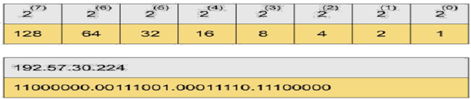

## Classless Inter Domain Routing(CIDR)

Class A has default subnet mask 255.0.0.0. that means first octet of the subnet mask has all on bits. In slash notation it would be written as /8, means address has 8 bits on. Class B has default subnet mask 255.255.0.0. that means first two octets of the subnet mask have all on bits. In slash notation it would be written as /16, means address has 16 bits on.

Class C has default subnet mask 255.255.255.0. that means first three octets of the subnet mask have all on bits. In slash notation it would be written as /24, means address has 24 bits on.

**Subnetting Class C Addresses**

In a Class C address, the first 3 octets i.e. 24 bits are defining the network and only 8 bits are available for defining the hosts. Class C IP addresses range from 192 to 223.The default subnet mask for Class C is 255.255.255.0 . CIDR notation of class C is /24, which means 24 bits from IP address are already consumed by network portion and we have 8 host bits to work with.

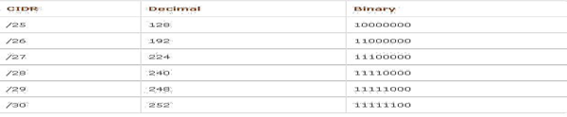

### Subnetting Class B Addresses

In a Class B address, the first 2 octets i.e. 16 bits are defining the network and only 16 bits are available for defining the hosts. Class C IP addresses range from 128 to 191.The default subnet mask for Class C is 255.255.0.0 .

### Subnetting Class A Addresses

In a Class A address, the first octets i.e. 8 bits are defining the network and only 24 bits are available for defining the hosts. Class C IP addresses range from 0 to 127.The default subnet mask for Class C is 255.0.0.0 .

### Subnetting Class D Addresses

A Class D address begins with binary 1110 in the first octet. First octet range 224 to 239.Class D address can be used to represent a group of hosts called a host group, or multicast group.

### Subnetting Class E Addresses

First octet of an IP address begins with 1111.First octet range 240 to 255. Class E addresses are reserved for experimental purposes and should not be used for addressing **hosts or multicast groups.**

### How to find subnet mask of a given IP address?

We cannot perform subnetting with default subnet mask and every classes have default subnet mask. Now find the host bits borrowed to create subnets and convert them in decimal. For example find the subnet mask of address 188.25.45.48/20 ? This address belong to class B and class B has default subnet mask 255.255.0.0[ /16 in CIDR. We borrowed 4 bits from hosts portion. As you know subnetting move from left to right and it cannot skip any network bit. So this subnet mask in binary would be 11111111. 11111111.11110000.00000000.In our example it would be 128+64+32+16+0+0+0+0 = 240. Our fourth octet has all bits off so its decimal value would be 0+0+0+0+0+0+0+0 =0. Our answer subnet mask would be 255.255.240.0

### How many subnets?

2x = number of subnets. x is the number of masked bits, or the 1s. For example, in 11000000, the number of ones gives us 22 subnets. In this example, there are 4 subnets.

### What are the valid subnets and block size?

256 – subnet mask = block size, or increment number. An example would be 256 – 192 = 64. The block size of a 192 mask is always 64. Start counting at zero in blocks of 64 until you reach the subnet mask value and these are your subnets. 0, 64, 128, 192.

### What are the total hosts per subnet?

Total hosts are the hosts available per subnet. To calculate total hosts use formula 2y = Total hosts. y is the number of host bits. For example in address 192.168.1.0/26 we have 32 - 26 [Total bits in IP address - Bits consumed by

network address] = 6. Total hosts per subnet would be 26 = 64.

### How many valid hosts per subnet?

2y– 2 = number of hosts per subnet. y is the number of unmasked bits, or the 0s. For example, in 11000000, the number of zeros gives us 26 – 2 hosts. In this example, there are 62 hosts per subnet. You need to subtract two for the **subnet address or starting address** and the **broadcast address**, which are not valid host. Valid hosts are the numbers between the subnets omitting all the 0s and all 1s. For example, if 64 is the subnet number and 12 is the broadcast address, then 65–126 is the valid host range—it’s always the numbers between the subnet address and the broadcast address.

### What is broadcast address of each subnet?

Broadcast address is the last address of subnet. This address is reserve for network broadcast, and cannot be assigned to any host. In above example

0 Subnet has broadcast address 63

64 Subnet has broadcast address 127

128 Subnet has broadcast address 191

192 Subnet has broadcast address 255

### What is the network address of each subnet?

Network address is the first address of subnet. This address is used to locate the network, and cannot be assigned to any host. In above example address 0,64,128,192 are the network address.

Network address is always the first IP address of subnet.

Broadcast address is always the last IP address of subnet ( IP address before the next subnet).

Valid hosts are the IP addresses between network address and broadcast address.

## Exercises:

* 1. What do you understand by logical addressing?

**Answer:**

The logical address is virtual address as it does not exist physically, therefore, it is also known as Virtual Address. This address is used as a reference to access the physical memory location by CPU.

* 1. Why we divide the range of ip address from 0 to 255 in classes?

**Answer:**

Each byte, or 8-bit segment of the address, is divided by a period and typically expressed as a number 0-255. Even though these numbers are typically expressed in decimal to aid in human comprehension, each segment is usually referred to as an octet to express the fact that it is a representation of 8 bits.

* 1. Difference between unicasting & multicasting? Give its example.

**Answer:**

**UNICASTING:**

In Unicasting, the data traffic flows from a single source node to a single destination node on the network. It is a 'one-to-one' type of data transmission between the sender and receiver.

**MULTICASTING:**

Multicast is a kind of transmission type in which a single source communicates a message to a group of devices.

* 1. What is CIDR or slash notation. Give the maximum and minimum range of each class.

**Answer:**

Classless Inter-Domain Routing is a method for allocating IP addresses and for IP routing.

|  |  |  |  |  |
| --- | --- | --- | --- | --- |
| Class A | Class B | Class C | Class D | Class E |
| 0.0.0.0 - 127.255.255.255 | 128.0.0.0 - 191.255.255.255 | 192.0.0.0 - 223.255.255.255 | 224.0.0.0 - 239.255.255.255 | 240.0.0.0 - 255.255.255.255 |

* 1. What is broadcast addressing?

**Answer:**

A broadcast address is a network address used to transmit to all devices connected in a network

* 1. Perform subnet on following ip 195.176.5.0/28.

**Answer:**

**Binary Subnet Mask: 11111111. 11111111. 11111111. 11110000**

**IP Class: C**

**Binary Id: 11000011.10110000.00000101.00000000**

**CIDR Notation: /**28

**Subnet ask:** 255.255.255.240

* 1. find the subnet mask only of the following ip address:

a) 192.168.60.20/28 b)202.50.6.7/26 c) 215.54.7.80/29

**Answer:**



**Binary Subnet Mask: 11111111. 11111111. 11111111. 11110000**

**IP Class: C**

**Binary Id: 11000000.10101000.00111100.0001**0100

**CIDR Notation: /**28

**Subnet ask:** 255.255.255.240



**Binary Subnet Mask: 11111111. 11111111. 11111111. 11000000**

**IP Class: C**

**Binary Id: 11001010.00110010.00000110.00**000111

**CIDR Notation: /**26

**Subnet ask:** 255.255.255.192



**Binary Subnet Mask: 11111111. 11111111. 11111111. 11111000**

**IP Class: C**

**Binary Id: 11010111.00110110.00000111.01010**000

**CIDR Notation: /**29

**Subnet ask:** 255.255.255.240